Llama 2 Lab on GCP

Sign up for Trial of Google Cloud



Enter payment info for trial (instructor will load via preloaded cards)

Deploy > New Project

Create

Vertex AI endpoint

Select 2 NVIDIA > Deploy

Wait

Search for Endpoint Attachments

Cloud overview > Model Registry

Check for deployed status

Click Cloud overview > Service Accounts

Click Create service account

Select Vertex AI

Assign the listed roles

Verify account created

Click Keys > Add key

Return to Model Registry and select Llama2

Select sample request

Copy the first gcloud snippet



Launch the CLI and past the auth code snippet

Click the link returned in the CLI and follow the popout window prompts

Copy the authorization code (last page) and put back into CLI

You should see a confirmation:

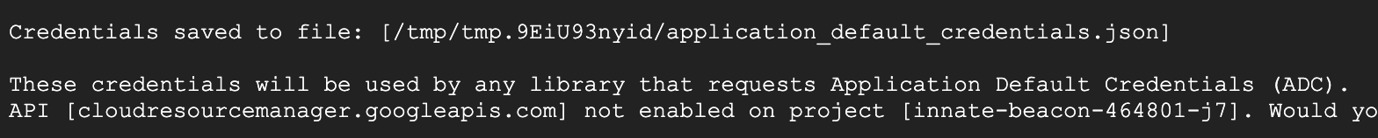

Copy the second snipped from sample request and run the prediction.

Submit the a response from the prediction.